Rose Stereograph Co.

LARGE ROSE; words 'Post Card' are shaded; appears both with and without the words 'real photo'; used 1914-16  R1 | 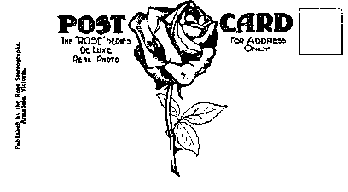

MEDIUM ROSE; stamp box with wavy outline; address shown as "Armadale" (1923)  R2 | 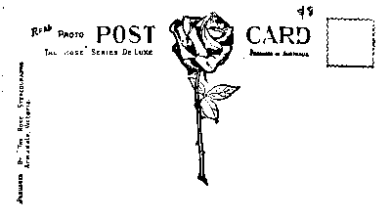

MEDIUM ROSE; stamp box with wavy outline; address shown as "Rose Post Cards, Sydney and Melbourne" (1928)  R2a | 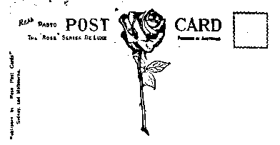

MEDIUM ROSE; stamp box with wavy outline; no address.

R2b

SMALL ROSE  Stamp box with dotted outline; address shown as 'Armadale' used 1922-29  R3 | 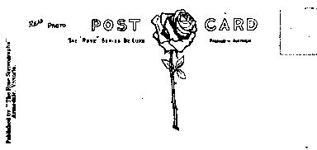

SMALL ROSE  Stamp box with dotted outline; address shown as 'Sydney and Melbourne'  R3a | 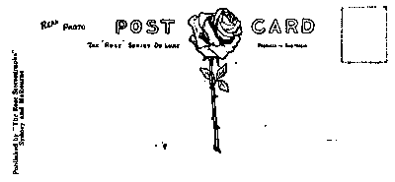

SMALL ROSE  Stamp box with dotted outline; address shown as 'Sydney and Melbourne'; Name shown as ‘Rose Post Cards’  R3b | 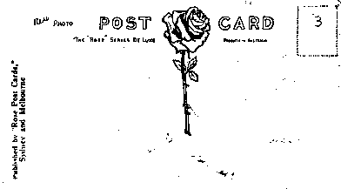

SMALL ROSE  No stamp box; Printing of words 'Post Card' light; company name in small type with serifs  R4 | 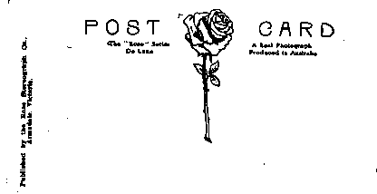

SMALL ROSE  No stamp box; Printing of words 'Post Card' in heavier weight; company name in sans-serif type; used 1946-48  R5 | 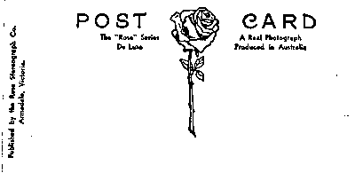

NO ROSE  Wording says 'This side for address only' (used 1915-33)  R7 | 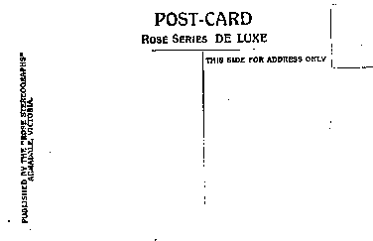

NO ROSE  Wording says For address only'  R8 | 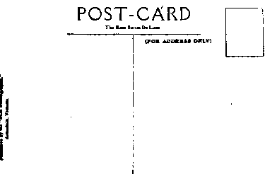

Note Ornate ‘A’ in ‘A Real Photograph’  R9 | 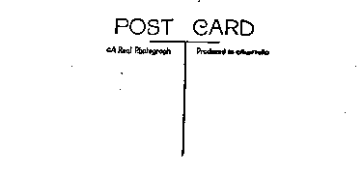

Note Simple ‘A’  R10 | 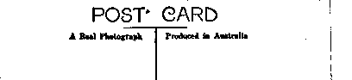

Note logo in stamp box position  R11 | 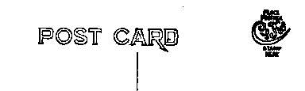

Note words 'space for communication' on L.H. side  R12 | 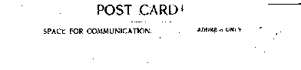

Rose 'Colourview': similar to R4, with a Glen Waverley address.

R13

If known only from glass negatives in LaTrobe Library, indicated by asterisk *

